# Question 01

## Part A

### Code

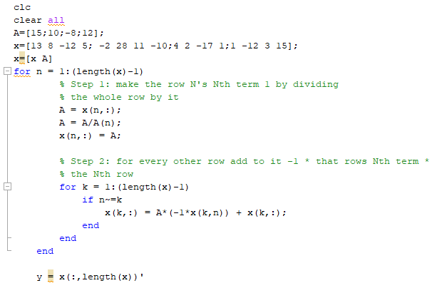

### Output

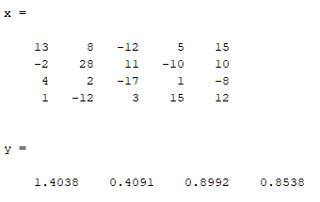

## Part B

### Code

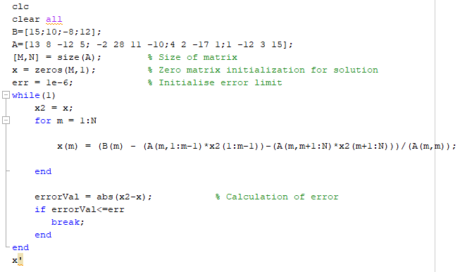

### Output

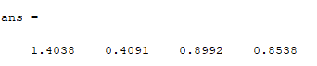

## Part C

### Code

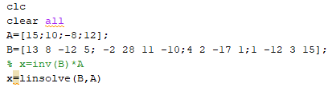

### Output

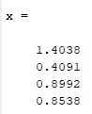

# Question 02

The Jacobi and Guess-Jorden are work for 600 equation and 600 unknown values. When we have a lot of equation and unknown, we can’t prefer to use these methods because its time taking.